A1128-ME-LANG-Moabite

 

Fig. 1. Moabite inscription fragment, ca 850 BCE

**Case no.: 2**

**Accession Number: A1128**

**Formal Label:** Moabite writing fragment, ca 850 BCE

**Display Description:** Moabite writing fragment, ca 850 BCE

**LC Classification: PJ4149.I5**

**Date or Time Horizon:** Iron Age II, 850 BCE

**Geographical Area:** **between Wadi Mujib and Wadi Hasa.**

**Map, GPS coordinates: 31.50201 35.77643; 31º30'7.22" N 35º46'35.14" E**



Fig. 2. Map of area of Bani Hamidah clan in 1895 and find spot. From Google Maps.

**Cultural Affiliation:** Moabite

**Medium:** limestone

**Dimensions:** H 62.32 mm/ 3.95 in; W 30.13 mm/ 2.68 in

**Weight: 168.9 gm/ 5.96 oz**

**Condition: original**

**Provenance:** Bani Hamidah Bedouin clan

**Discussion:**

This fragment contains one of the few Iron Age II Moabite inscriptions dating to ca 850 BCE. Moabite is an extinct Canaanite language, which was written in the Phoenician alphabet and was spoken in the region of Moab (central-western Jordan) ca 1000-500 BCE. This fragment was found ca. 1900 CE n of Wadi Mujib near Dibon (modern Dhiban, Jordan) an area which the Bani Hamida clan controlled before the establishment of the Emirate of Transjordan. Frederick Jones Bliss an Amherst College graduate (1880), who had trained under Flinders Petrie in Egypt and then had worked as an archaeologist at the site of Tell el-Hesi in 1891-1892, was camping at Mount Zion in Jerusalem in March 1895 when he visited "the sheikhs of the Hamideh” and noted that they “were very civil and anxious to show us all the *torn stones,* which is their phrase covering inscriptions and ornamentation" (Palestine Exploration Fund 1895: 214). This specimen is one of the “torn stones” referred to and is one of the few pieces of primary evidence for the Moabite language. This fragment depends for its transcription and translation on the only known extensive Moabite text, the Mesha Stele (also known as the Moabite stone) dating to ca 850 BCE, which is close to the dating of this fragment based on paleography.

The Mesha Stele was discovered by Frederick Augustus Klein, an Anglican missionary, at ancient Dibon on August 1868. Charles Simon Clermont-Ganneau had a papier-mâché impression made of it, but in 1869 the villagers with whom the stele had been left had a dispute over its ownership and decided to break it into pieces to distribute its fortune. They heated the stele and then poured cold water on it thereby cracking it into pieces. Several fragments were later recovered and reassembled together with the missing fragments supplied by the papier-mâché impression. The reassembled stele is now in the Louvre Museum (Lemaire 1994). On the stele King Mesha of Moab, for whom the stele is named, related how Chemosh, the Moab god, had been angry with his people and had allowed them to be subjugated to Israel, but then he relented and aided in throwing off the yoke of the House of David and of Israel and its god Yahweh: this is the earliest, most extensive inscription that refers to Israel (the "House of Omri"), Yahweh and Judah ("House of David") (Lemaire 1994):

**“I am Mesha, son of Chemosh king of Moab, the Daibonite. My father reigned over Moab for thirty years, and I reigned after my father. And I made this high-place for Chemosh in Kerekhoh a high-place of salvation, because he had saved me from all assailants, and because he had let me see my pleasure upon all them that hated me. Omri was king of Israel and he afflicted Moab for many days, for Chemosh was being angry with his land. And his son succeeded him, and he also said, I will afflict Moab. In my days said he thus, and I saw my pleasure on him and his house. And Israel perished with an everlasting destruction; now Omri had taken possession of the land of Mehdeba. And it dwelt there in his days and half the days of his son, forty years; and Chemosh restored it in my days. And I built Baal Meon and I made in it the reservoir, and I built Kiryathen. Now the men of Gad had dwelt in the land of Ataroth from of old. And the king of Israel built for himself Ataroth. And I warred against the city and seized it. And I slew all the people of the city, a gazing-stock to Chemosh and to Moab. And I captured thence the altar-hearth of Daedoh and I dragged it before Chemosh in Keriyyoth . And I settled there in to men of Sheren and the men of Makharath. And Chemosh said unto me, “Go, take Nebo against Israel”. And I seized it, and slew by night and warred against it from the break of dawn unto noon. And I seized it, and slew all of it, 7,000 men and male sojourners and women and female sojourners and maidens. For to Ashtor-Chemosh had I devoted it. And I took thence the vessels of JHWH, and I dragged them before Chemosh. Now the king of Israel had built Jahas and dwelt in it, when he warred against me. And Chemosh drove him out from me. And I took of Moab 200 men, all its chiefs. And I brought it against Jahas, and seized it, to add it into Daibon. I built Kerekhoth, the wall of the Woods and the wall of the Mound. And I built its gates and I built its towers. And I built the King’s house, and I made the two reservoirs of water in the Midst of the city. Now there was no cistern in the midst of all the city, in Kerekhoth, and I said to all the people, make you every man a cistern in his house. And I cut out the cutting of Kerekhoth with the prisoners of Israel. And I built Aroer, and I made the highway by the Arnon. I built Beth-Bamoth, for it was overthrown. I built Beser for ruins had it become. And the chiefs of Daibon were fifty, for all Daibon was obedient. And I reigned over one hundred chiefs in the cities which I added to the land. And I built Mehdeba and Beth-Diblathen. And Beth-Baal-Meon. And I took thence the sheep-masters... the sheep of the land. And as for Horonen, there dwelt there in...And Chemosh said unto me, Go down, fight against Horonen. And I went down...And Chemosh restored it in my days...”**

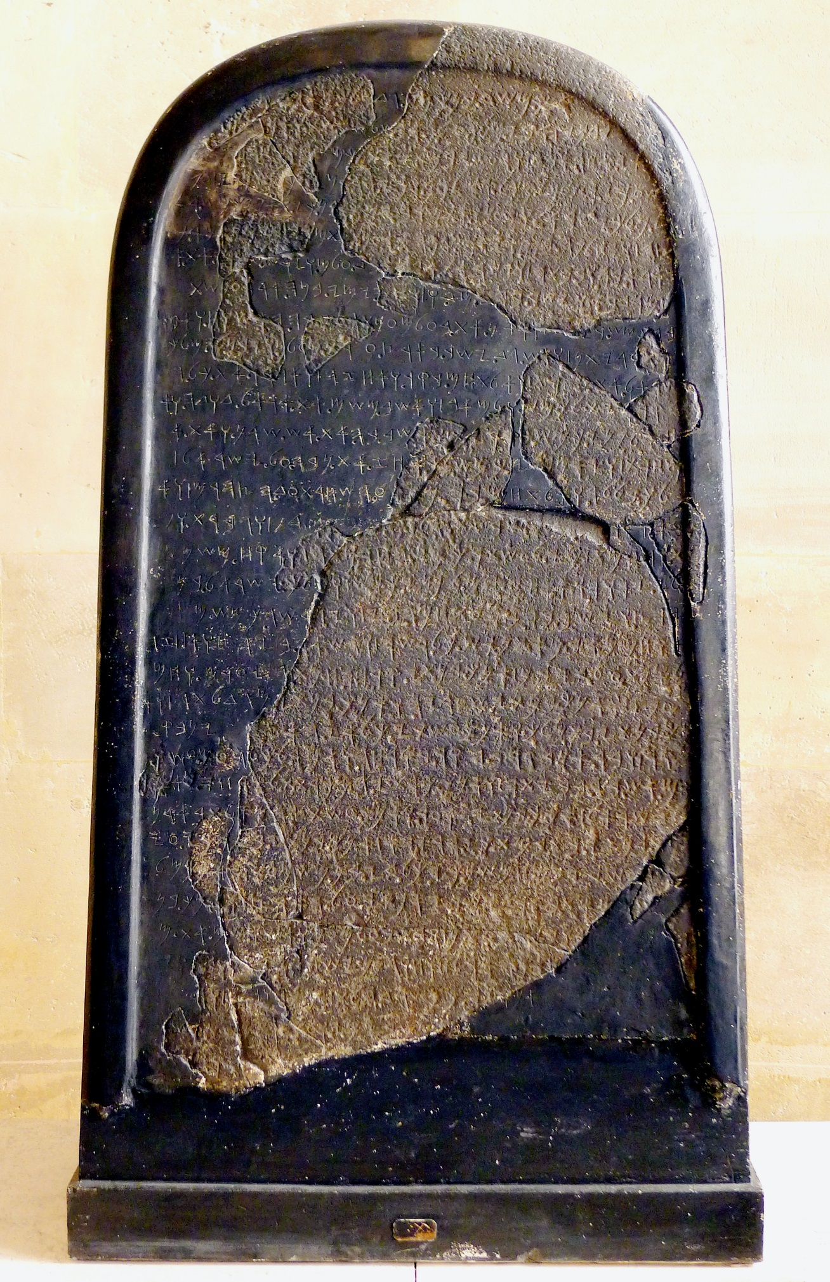

The Mesha stele Louvre Museum. From <https://upload.wikimedia.org/wikipedia/commons/thumb/7/7b/P1120870_Louvre>

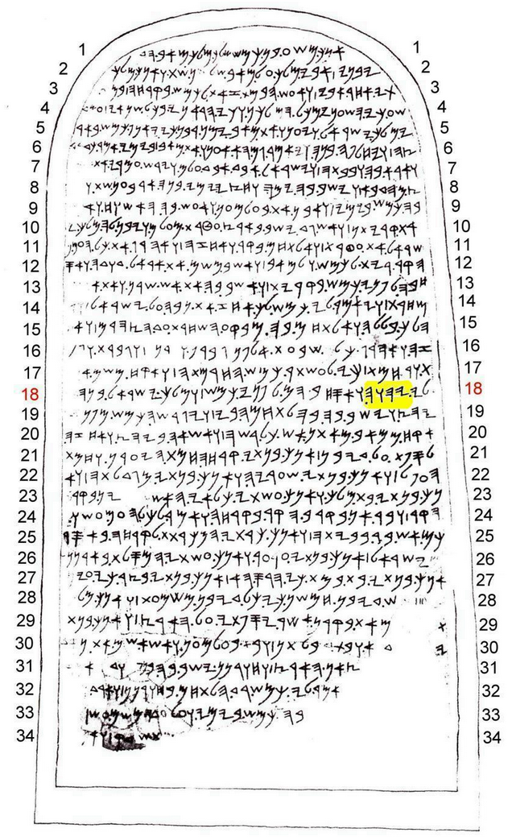

The Meshe stele transcription.



Fig. 3. The “Explorers’ camp” of F. J. Bliss and A. C. Dickie on the slopes of Mount Zion, Jerusalem, from a photograph taken by Rev. A. E. Beckton and published in Bliss and Dickie 1898: 352. Dibon was about 60 miles (96.56 km) ese of this camp. From <http://www.flickr.com/photos/palestineexplorationfund/5226264921/>

|  |  |  |  |  |  |  |  |  |
| --- | --- | --- | --- | --- | --- | --- | --- | --- |
| **Hieroglyph** | **Proto-Sinaitic** | [**IPA**](https://en.wikipedia.org/wiki/IPA)**value** | **reconstructed name** | [**Phoenician**](https://en.wikipedia.org/wiki/Phoenician_alphabet) | [**Paleo-Hebrew**](https://en.wikipedia.org/wiki/Paleo-Hebrew_alphabet)  **Moabite** | [**Aramaic**](https://en.wikipedia.org/wiki/Aramaic_alphabet) | [**Hebrew**](https://en.wikipedia.org/wiki/Biblical_Hebrew) | [Archaic Greek](https://en.wikipedia.org/wiki/Archaic_Greek_alphabets), [Modern Greek](https://en.wikipedia.org/wiki/Greek_alphabet), [Etruscan](https://en.wikipedia.org/wiki/Old_Italic_script#Etruscan_alphabet), and [Latin](https://en.wikipedia.org/wiki/Latin_alphabet) |
| |  |  | | --- | --- | | |  | | --- | | F1 | | | [Aleph](https://en.wikipedia.org/wiki/File:Proto-Canaanite_-_aleph.png) | /ʔ/ | [ʾalp](https://en.wikipedia.org/wiki/%CA%BEalp) "ox" | [Aleph](https://en.wikipedia.org/wiki/File:Phoenician_aleph.svg) | [Aleph](https://en.wikipedia.org/wiki/File:Early_Aramaic_character_-_Alaph.png) | [Aleph.svg](https://en.wikipedia.org/wiki/File:Aleph.svg) | א | [Greek Alpha 03.svg](https://en.wikipedia.org/wiki/File:Greek_Alpha_03.svg) [Α](https://en.wikipedia.org/wiki/Alpha_(letter)) [𐌀 A](https://en.wikipedia.org/wiki/A) |
| |  |  | | --- | --- | | |  | | --- | | O1 | | | [Bet](https://en.wikipedia.org/wiki/File:Proto-Canaanite_-_bet.png) | /b/ | [bet](https://en.wikipedia.org/wiki/Bet_(letter)) "house" | [Beth](https://en.wikipedia.org/wiki/File:Phoenician_beth.svg) | [Bet](https://en.wikipedia.org/wiki/File:Early_Aramaic_character_-_Beth.png) | [Beth.svg](https://en.wikipedia.org/wiki/File:Beth.svg) | ב | [Greek Beta 16.svg](https://en.wikipedia.org/wiki/File:Greek_Beta_16.svg) [Β](https://en.wikipedia.org/wiki/Beta_(letter)) [𐌁 B](https://en.wikipedia.org/wiki/B) |
| |  |  | | --- | --- | | |  | | --- | | A28 | | | [Heh](https://en.wikipedia.org/wiki/File:Proto-Canaanite_-_heh.png) | /h/ | *hll* "jubilation" > *he* "window" | [He](https://en.wikipedia.org/wiki/File:Phoenician_he.svg) | [Heh](https://en.wikipedia.org/wiki/File:Early_Aramaic_character_-_heh.png) | [He0.svg](https://en.wikipedia.org/wiki/File:He0.svg) | ה | [Greek Epsilon archaic.svg](https://en.wikipedia.org/wiki/File:Greek_Epsilon_archaic.svg) [Ε](https://en.wikipedia.org/wiki/%CE%95) [𐌄 E](https://en.wikipedia.org/wiki/E) |
| |  |  | | --- | --- | | |  | | --- | | D46 | | | [Khof](https://en.wikipedia.org/wiki/File:Proto-Canaanite_-_khof.png) | /k/ | [kaf](https://en.wikipedia.org/wiki/Kaph) "palm of hand" | [Kaph](https://en.wikipedia.org/wiki/File:Phoenician_kaph.svg) | [Khof](https://en.wikipedia.org/wiki/File:Early_Aramaic_character_-_khof.png) | [Kaph.svg](https://en.wikipedia.org/wiki/File:Kaph.svg) | כ, ך | [Greek Kappa normal.svg](https://en.wikipedia.org/wiki/File:Greek_Kappa_normal.svg) [Κ](https://en.wikipedia.org/wiki/Kappa) [𐌊 K](https://en.wikipedia.org/wiki/K) |
| |  |  | | --- | --- | | |  | | --- | | N35 | | | [Mem](https://en.wikipedia.org/wiki/File:Proto-Canaanite_-_mem.png) | /m/ | [mayim](https://en.wikipedia.org/wiki/Mayim) "water" | [Mem](https://en.wikipedia.org/wiki/File:Phoenician_mem.svg) | [Mem](https://en.wikipedia.org/wiki/File:Early_Aramaic_character_-_mem.png) | [Mem.svg](https://en.wikipedia.org/wiki/File:Mem.svg) | מ, ם | [Greek Mu 04.svg](https://en.wikipedia.org/wiki/File:Greek_Mu_04.svg) [Μ](https://en.wikipedia.org/wiki/Mu_(letter)) [𐌌 M](https://en.wikipedia.org/wiki/M) |
| |  |  | | --- | --- | | |  | | --- | | I10 | | | [Nun](https://en.wikipedia.org/wiki/File:Proto-Canaanite_-_nun.png) | /n/ | *naḥš* "snake" > [*nun*](https://en.wikipedia.org/wiki/Nun_(letter)) "fish" | [Nun](https://en.wikipedia.org/wiki/File:Phoenician_nun.svg) | [Nun](https://en.wikipedia.org/wiki/File:Early_Aramaic_character_-_nun.png) | [Nun.svg](https://en.wikipedia.org/wiki/File:Nun.svg) | נ, ן | [Greek Nu 01.svg](https://en.wikipedia.org/wiki/File:Greek_Nu_01.svg) [Ν](https://en.wikipedia.org/wiki/%CE%9D) [𐌍 N](https://en.wikipedia.org/wiki/N) |
| |  |  | | --- | --- | | |  | | --- | | D4 | | | [Ayin](https://en.wikipedia.org/wiki/File:Proto-Canaanite_-_ayin.png) | /ʕ/ | [ʿen](https://en.wikipedia.org/wiki/%CA%BFen) "eye" | [Ayin](https://en.wikipedia.org/wiki/File:Phoenician_ayin.svg) | [Ayin](https://en.wikipedia.org/wiki/File:Early_Aramaic_character_-_ayin.png) | [Ayin.svg](https://en.wikipedia.org/wiki/File:Ayin.svg) | ע | [Greek Omicron 04.svg](https://en.wikipedia.org/wiki/File:Greek_Omicron_04.svg) [Ο](https://en.wikipedia.org/wiki/Omicron) [𐌏 O](https://en.wikipedia.org/wiki/O) |
| |  |  | | --- | --- | | |  | | --- | | D1 | | | |  | | --- | | D19 | | | | [Resh](https://en.wikipedia.org/wiki/File:Proto-Canaanite_-_resh.png) | /r/ | [roʾš](https://en.wikipedia.org/wiki/Resh) "head" | [Res](https://en.wikipedia.org/wiki/File:Phoenician_res.svg) | [Resh](https://en.wikipedia.org/wiki/File:Early_Aramaic_character_-_resh.png) | [Resh.svg](https://en.wikipedia.org/wiki/File:Resh.svg) | ר | [Greek Rho pointed.svg](https://en.wikipedia.org/wiki/File:Greek_Rho_pointed.svg) [Greek Rho 03.svg](https://en.wikipedia.org/wiki/File:Greek_Rho_03.svg) [Ρ](https://en.wikipedia.org/wiki/Rho_(letter)) [𐌓 R](https://en.wikipedia.org/wiki/R) |
| |  |  | | --- | --- | | |  | | --- | | Aa32 | | | [Shin](https://en.wikipedia.org/wiki/File:Proto-Canaanite_-_shin.png) | /ʃ/ | *šimš* "[sun](https://en.wikipedia.org/wiki/Apep)" > *šin* "tooth" | [Sin](https://en.wikipedia.org/wiki/File:Phoenician_sin.svg) | [Shin](https://en.wikipedia.org/wiki/File:Early_Aramaic_character_-_shin.png) | [Shin.svg](https://en.wikipedia.org/wiki/File:Shin.svg) | ש | [Greek Sigma normal.svg](https://en.wikipedia.org/wiki/File:Greek_Sigma_normal.svg) [Greek Sigma 18.svg](https://en.wikipedia.org/wiki/File:Greek_Sigma_18.svg) [Σ](https://en.wikipedia.org/wiki/Sigma) [𐌔 S](https://en.wikipedia.org/wiki/S) |
| |  |  | | --- | --- | | |  | | --- | | Z9 | | | [Tof](https://en.wikipedia.org/wiki/File:Proto-Canaanite_-_tof.png) | /t/ | *tāw* "mark" | [Taw](https://en.wikipedia.org/wiki/File:Phoenician_taw.svg) | [Tof](https://en.wikipedia.org/wiki/File:Early_Aramaic_character_-_tof.png) | [Taw.svg](https://en.wikipedia.org/wiki/File:Taw.svg) | ת | [Greek Tau 02.svg](https://en.wikipedia.org/wiki/File:Greek_Tau_02.svg) [Τ](https://en.wikipedia.org/wiki/%CE%A4) [𐌕 T](https://en.wikipedia.org/wiki/T) |

Fig. Collation of ancient scripts from